1. **Setup React Typescript Project**
   1. Install – nodejs
   2. Create a project folder - open in vs code
   3. Install typescript – **npm install -g typescript**
   4. Create react project with typescript

**npx create-react-app projectname --template typescript**

1. **React Hooks Concepts**
2. **ReactReducer**

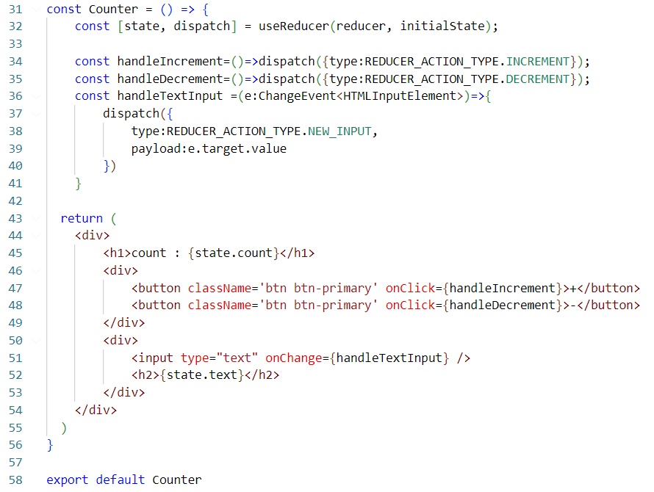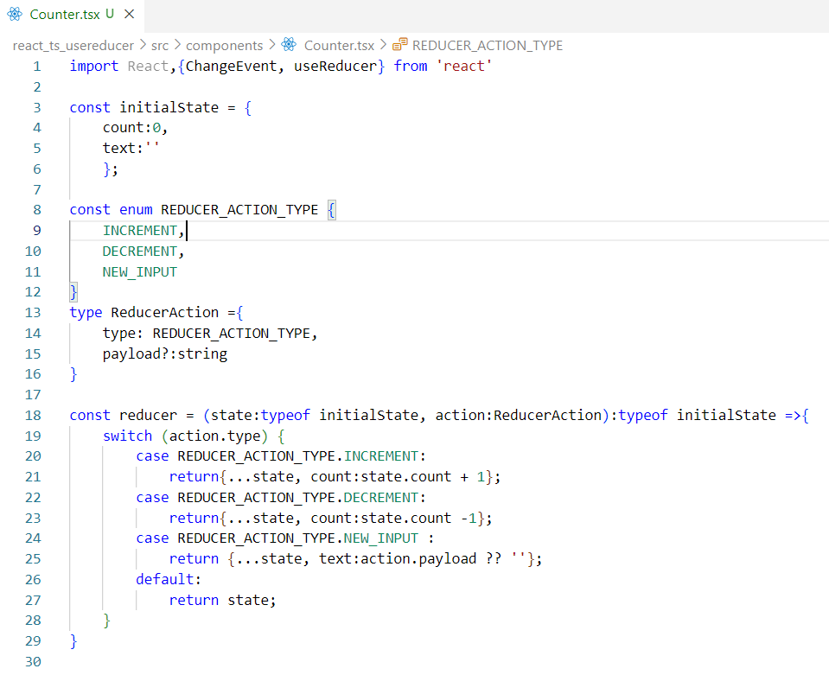

1. **Types Concepts**
2. **ReactNode**

**Definition and Purpose:**

ReactNode is a TypeScript type that represents a node in the React rendering tree. A node in this context can be any piece of content that can be rendered by React.

**Types of Content Allowed:**

ReactNode is quite inclusive and can represent a wide range of content types. This includes:

* JSX Elements: Components or HTML elements.
* Strings and Numbers: Simple text or numeric content.
* Arrays of React Nodes: An array containing any combination of the above.
* Fragments (<></>): A way to return multiple elements without introducing an additional DOM element.

**Usage in Component Props**:

When defining a component in React, you often want to allow for flexible content. For example, if you are creating a generic container component, you might want it to be able to contain any kind of content - text, images, other components, etc.

